A multi model database. Why should you use it?

Multi-model direction systems unify multiple info systems into one. Multi-model databases provide the modeling edges of polyglot persistence whereas not having to hunt out ways in which to combine utterly completely different models. rather than operational with varied models and finding ways in which to incorporate them on, multi-model information’s provides a singular engine for diverse info kinds. The versatile approach permits storing data in various ways in which. The result is: Agile and versatile programming. Reduced data redundancy.
An info management answer that delivers on these true multi-model information capabilities will empower organizations with the lightsomeness and suppleness to tackle advanced use cases whereas reducing information storage and reckon costs, destruction info silos, and whereas not compromising on efficiency or ease-of-use.
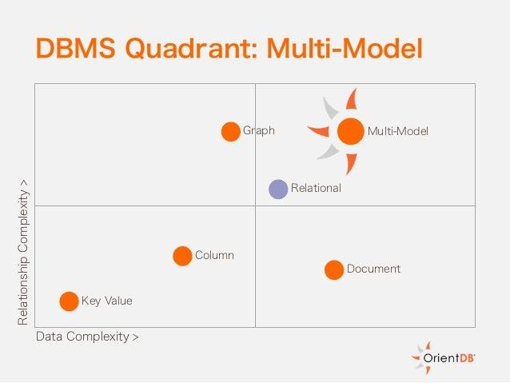
Types of Databases
- Arango DB - A native multi-model software with one search language and support for 3 knowledge models: key-value pairs, graphs, or documents. however, Arango DB doesn’t support SQL.
- Couchbase - A multi-model software with native processing support for key-value pairs and JSON documents, and partial (not full) text search.
- Redis - A multi-model software with native key-value capabilities and support for JSON document, graph, statistic, full text search, and AI (AI). however, Redis lacks its own search language and offers a restricted vary of queries with basic operators.
- Orient DB - A native multi-model software with support for graphs, documents, and key-values. Orient DB integrates several supported knowledge sorts at the core level, however, offers multiple knowledge compartmentalization choices that modify in capabilities and performance for every knowledge kind. a number of these indices don’t perform well with sure knowledge sorts; thus, users can get to reindex the info (added value and complexity) to support novel use cases.
Notable among the emergent information kinds among the large data and cloud computing era is that the NoSQL information in its various categories. Multi model databases supply a technique to switch such environments. The growing adoption of NoSQL code burning the thought of "polyglot persistence," that holds that organizations must be compelled to use a combination of information technologies to store the divergent kinds of data they generate and collect.

Use cases facilitate offer a concept of however multi-model databases work. Analyzing sensible examples offer higher insight into however multiple models work along in one system.

- Storing and Managing Multiple knowledge Sources
A typical IT system uses varied knowledge sources. The hold on info isn't forever within the same format or info. Multiple formats produce a posh system, creating it laborious to keep up and search through knowledge. Storing knowledge during a multi-model info makes administration easier. Everything is in one info, that reduces the time required to store and manage knowledge from completely different sources.
- Extending Model options
Multi-model databases offer extensions between models. options from some models facilitate supplement the shortcomings of different models. For example, querying knowledge in JSON format exploitation SQL queries are easy. there's no got to modify the first knowledge supply. Extensibility reduces processing time and eliminates the requirement for extract, rework and cargo (ETL) systems.
- Hybrid knowledge Environments
A typical knowledge atmosphere keeps operational knowledge break free analytical. {the knowledge the info the information} for analysis should be remodeled and hold on during a completely different place from the operational data. The information duplicates, decreasing knowledge quality. Likewise, the separated house creates maintenance overhead. each databases want policy administration in addition as backup management. A multi-model info provides a hybrid approach to knowledge storage. A unified knowledge hub for storing transactional and extracting analytical knowledge is easier to keep up.
Azure Cosmos dB natively supports multiple information models as well as documents, key-value, graph, and column-family. The core content-model of Cosmos DB’s info engine relies on atom-record-sequence (ARS). Atoms contains a tiny low set of primitive varieties like string, bool, and number. Records area unit structs composed of those varieties. Sequences area unit arrays consisting of atoms, records, or sequences. The info engine will with efficiency translate and project completely different information models onto the ARS-based information model. The core information model of Cosmos dB is natively accessible from dynamically typewritten programming languages and might be exposed as-is as JSON.
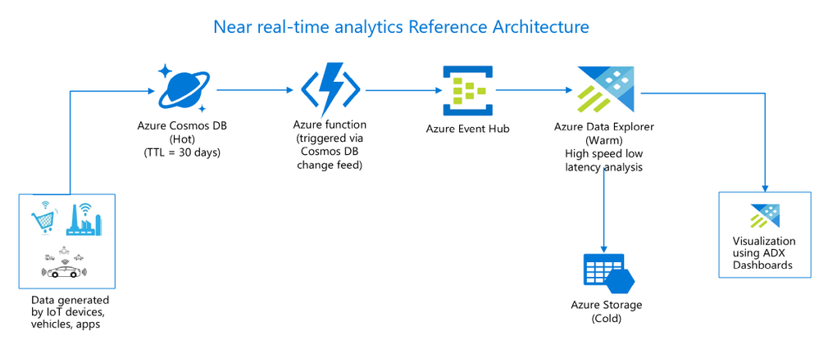
A well-known example with this variety of implementation is Microsoft’s cloud-based Azure Cosmos dB. Cosmos dB stores information within the low-level Atom-Record-Sequence (ARS) format, providing an info engine that may project different common models onto this illustration. Users will expose the ARS information as JSON or use one amongst many info arthropod genus for information access and querying. With support for 5 information models, each relative and unstructured, Cosmos dB feels like a high-functioning multi-model info -- however a more in-depth explore the implementation tells a rather totally different story. These samples of multi-model support are basically band aids underneath the hood that limit practicality to support the models themselves. for example, there are basic relative limitations with Cosmos DB’s ability to support teams by or joins.
Cosmos dB doesn't truly give one unified info with multi-model support. once users produce a info instance in a very instrumentation, they need to choose the foremost relevant API for his or her specific use case at a similar time. This determines not solely the API language which will be used for access and queries; however additionally however the info is going to be persisted in storage.
In short, a native multi-model info has one core, one query language, but multiple data models. A native multi-model info is also a mix of the many data stores in on system. you may build superior applications and scale horizontally exploitation all data models to their full extent. you may store data as key/value pairs, graphs or documents and would possibly access your data seamlessly with one declarative query language, combining completely different models in a {very} very single question.

